BlewMinds Website – Corporate StoryTelling


“People forget facts, but they remember stories”
- Joseph Campbell
Let’s Talk About Your Story


Stories have power. Stories build connection. Stories create a sense of belonging.
The Art of Corporate StoryTelling lives in anyone who has the passion & hunger to learn. Stories delight, enchant, touch, teach, recall, inspire, motivate & challenge. They help us understand & empathize. Effective StoryTelling imprints a picture on our minds.
According to research, 92% of consumers want brands to make ads which feel like a story. Consequently, stories often pack more punch than sermons. It has been found that facts are approximately 22 times more likely to be remembered if they are part of a story.

StoryTelling Frameworks

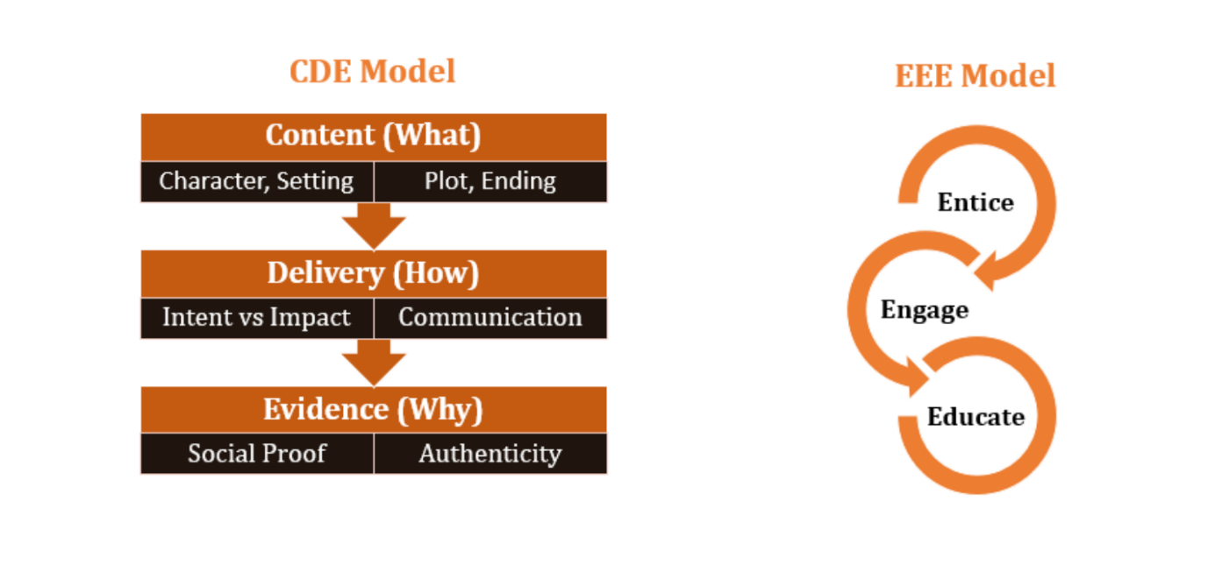

At BlewMinds, we work on the ‘Inside’ to make stories powerful on the ‘Outside’ so that powerful StoryTelling becomes your second nature. We focus on the individual side of Personal Branding, the business side of Organization Branding & the market side of Social Media Branding. These 3 tenets put together become a powerful deployment ground of StoryTelling to impact, influence & inspire.

Simply put, Corporate StoryTelling is the art of communicating feelings, data, information, using experiences & narratives to express yourself effectively in the corporate world or even in a professional setting. Corporate StoryTelling requires creativity, connecting the dots, imagination, being honest with oneself, self-disclosure & the deep ability to bare one’s heart completely without any fears of vulnerability.

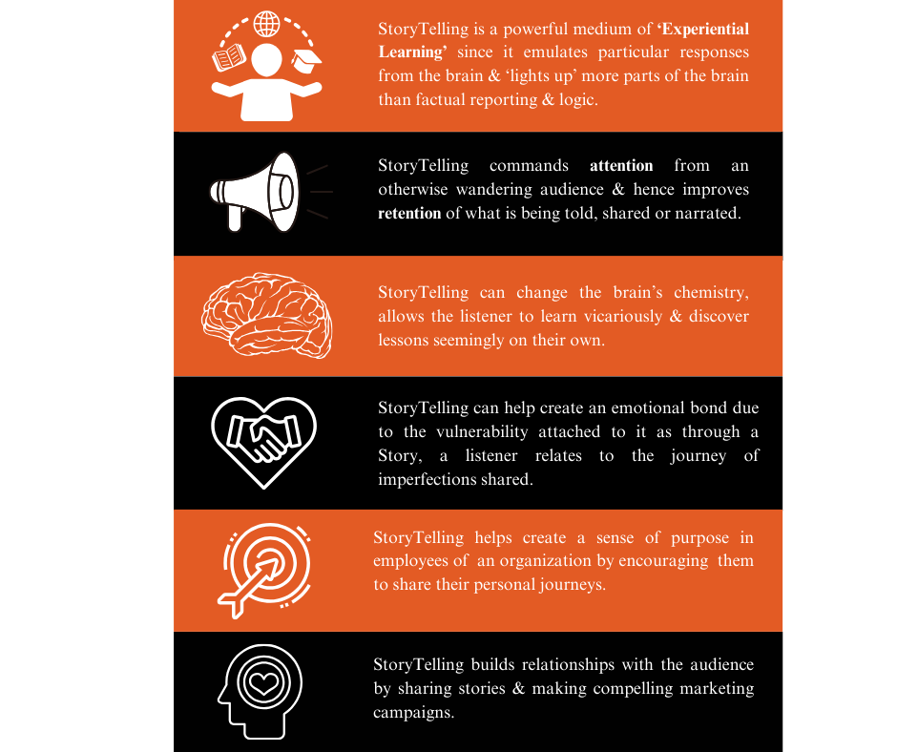

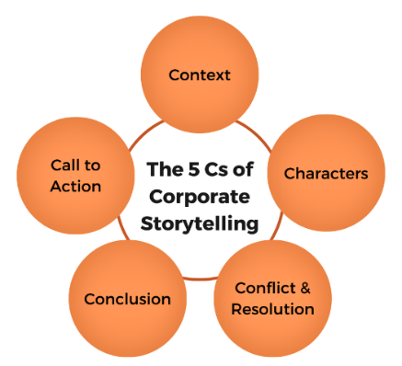
Effective StoryTelling can feed the human mind & heart which crave emotional connection. We are not moved to action by mere data dumps, dense PowerPoint slides or Spreadsheets packed with figures. When we see or hear factual arguments, we become logical, critical & skeptical. But when we are absorbed in a good story, we drop our guards!
Paradoxically, today, Corporate StoryTelling is also about communicating our logic, data, heavy information, facts, figures with stories woven together with powerful narratives.

Let’s Talk About Your Story

The core of a Good Story
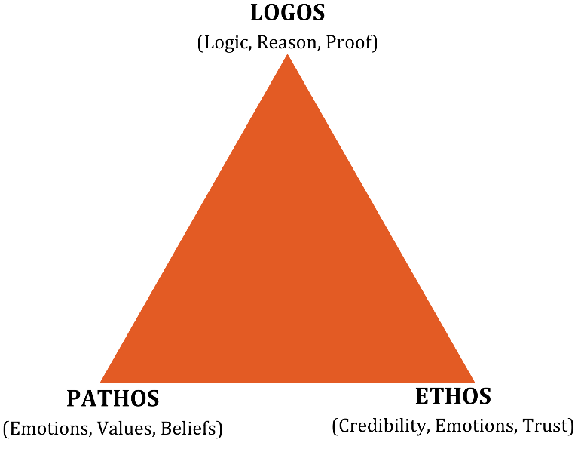

We help our clients master the Art of StoryTelling by integrating Logos (logic, reason, proof), Pathos (emotions, values, beliefs), & Ethos (credibility, emotions, trust). Our Global Story Coaching frameworks are designed to refine your StoryTelling skills, enhance your ability to build influential relationships, & improve stakeholder management. Through these frameworks, we provide long-term recall for developing persuasive narratives that echo across diverse audiences & drive meaningful connections.

StoryTelling at BlewMinds entails the following offering



Our Brand StoryTelling programs equip individuals to weave narratives which aid engagement of specific audiences, shape their & their company's identity beyond traditional Marketing methods. We employ effective StoryTelling strategies to powerfully communicate information about your product, brand, or company. Brand StoryTelling helps achieve:
- Building Brand Value
- Building & sustaining Brand Recall
- Enabling Brand Identity
- Improving Brand Resonance


Our Data StoryTelling programs help clients effectively communicate significance of data, highlighting its intelligent relevance & practical impact. We aid you with breaking down enormous amount of data into simplified formats, leading to insightful stories & analytics to influence diverse Target population. Data StoryTelling helps achieve:
- Data Simplification for meaningful impact
- Communicating Data powerfully in the form of Stories
- Engagement & Retention
- Enhancing Collaboration using Analytics



Our Leadership StoryTelling programs help you define your Leadership Value Proposition effectively through StoryTelling by exposing you to intelligent Leadership StoryTelling Frameworks. We help you clearly articulate what sets you apart, how you can stand out as an impactful leader for your stakeholders & audience. Leadership StoryTelling helps achieve:
- An Inspiring Vision
- Better understood & implemented Values
- Bonds & Connections
- Changing Mindsets



Our Organizational StoryTelling programs enable you craft captivating narratives about your organization, integrating Vales, Beliefs, Behaviours, Systems & Cultural Artifacts. This StoryTelling approach focuses on connecting, engaging, & inspiring stakeholders through meaningful stories. Organisational StoryTelling helps achieve:
- Cultural Cohesion
- Customer Connection
- Employee Engagement
- Effective Communication
Let’s Talk About Your Story

Benefits of StoryTelling
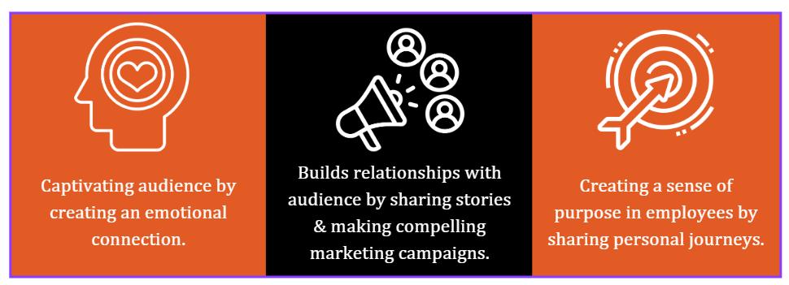

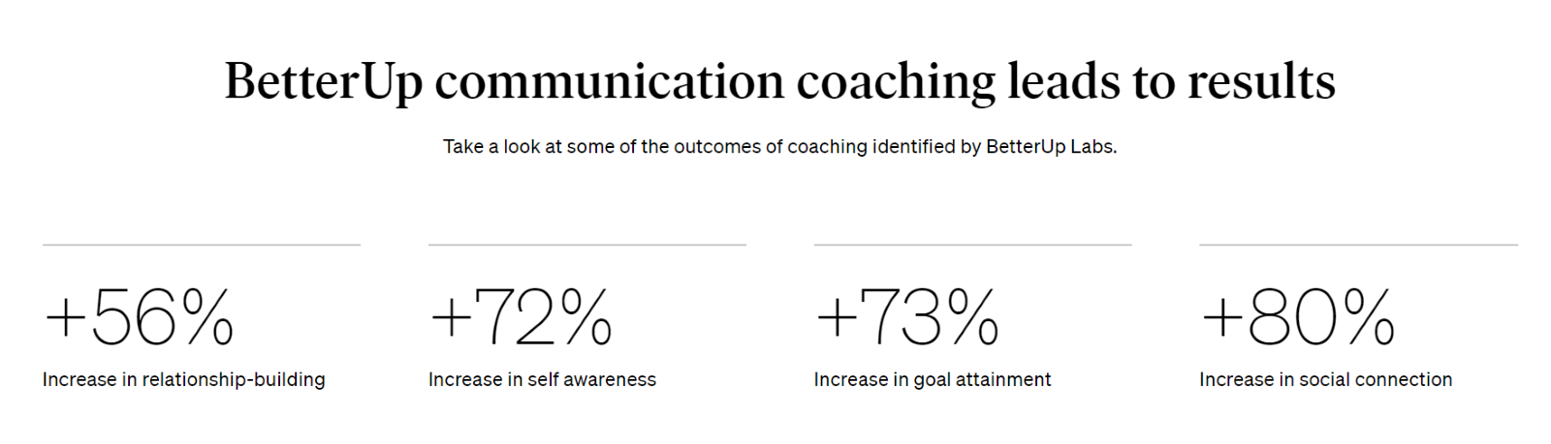

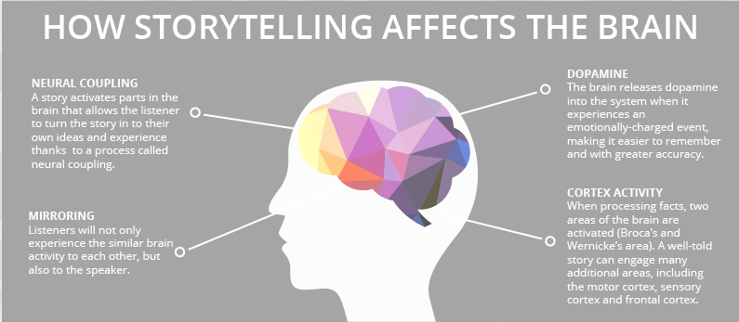

Form
FAQs
1. What is Corporate StoryTelling?
Ans. StoryTelling in the corporate world is about creating compelling stories that the audience identify & connect with deeply, conveying a brand's message, values, & vision effectively. We know that a well-told story can evoke emotions, inspire action, & create a loyal customer base. At BlewMinds, we specialize in crafting powerful, memorable, & emotive stories that captivate & engage your audience. Our expertise lies in understanding the essence of your brand & translating it into narratives that not only convey your core values but also attract & retain valuable customers.

2. How can StoryTelling benefit your business?
Ans. StoryTelling significantly enhances individual & organizational Brand appeal by forging emotional connections with customers, clearly conveying your values, & differentiating your offerings. At BlewMinds, our StoryTelling expertise ensures higher engagement, builds lasting trust, & drives sustained business growth. Let us help you tell your story & watch your Brand thrive.

3. Why should you integrate StoryTelling in Brand Management?
Ans. By integrating StoryTelling into brand management, BlewMinds can help you create an effective narrative that helps your audience identify with you, your brand, strengthen your brand identity, & differentiate your Brand from competition. It helps create consistent, positive brand association & promotes customer loyalty.

4. What makes our StoryTelling services unique?
Ans. BlewMinds’ StoryTelling services are distinguished by a deep & empathic understanding of individuals. Using a strategic approach to narrative development, we help individuals, organisations, leaders build their story, focus on creating relatable & engaging stories that drive real, tangible business outcomes. Our StoryTelling techniques focus on various global frameworks including Ethos, Pathos & Logos where information, data, emotions & values are interwoven to help leaders tell their stories impactfully to the world.

5. Can StoryTelling help with Internal Communications?
Ans. Yes, via StoryTelling, we at BlewMinds, can help you improve Internal Communications by making complex information simpler & more relatable, fostering a stronger organizational culture, motivating employees, teams through different yet unique narratives & personal journeys providing them with a sense of purpose.

Keywords: Corporate StoryTelling | Brand StoryTelling | Leadership StoryTelling | Management | Communications | organizational culture
Focus: Corporate StoryTelling
Meta Description: At BlewMinds, Corporate StoryTelling refers to impact, influence & inspire. Read more to know about what makes our StoryTelling services unique.

